Kingdom of Saudi Arabia

Ministry of Education
Jouf University
Vice-Rectorate
Community Service & Continuous Education-CSCE

Report of Program - Titled
“****”
( )Lecture ( )Training Program ( ) Workshop ( )Other….
Community Service & Continuous Education-CSCE

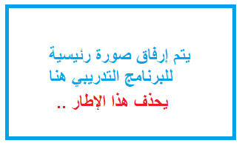
**/ ** /1440 هـ - **/ **/ 2019 م

Title of Program
****
Location of the Program
Sakaka | Male-students’ section | Training Hall- Skills Development Center-Jouf University
 | Female-students’ section | Female-students’ Complex- Building D- Hall 129
Day & Date
Example: Wednesday 17/ 10/ 2018 AD
Organized By:
Community Service & Continuous Education-CSCE - Vice-Rectorate - Jouf University
Trainer/lecturer
Dr. **** - Assistant Professor- Jouf University
Program Period
10 am- 2 pm
Targeted Group/Trainees
Teaching Faculty Members
Attendees
Sakaka | Male section | 20
 | Female section | 25

Supervised By
Male-students’ section Female-students’ section Dr. *** Dr. ***
Program Themes
- *
- *
- *
- *
- *
- *
Notes
- *****

Images from the Program

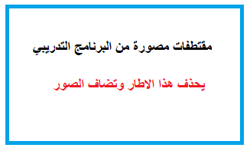

We Ask the Almighty God (Allah) to Bless all Efforts for Such Work.

