ALJOUF UNIVERSITY
2016
INFECTION CONTROL
POLICY MANUAL

College of Dentistry

Infection Control
Policy Manual

Infection Control Unit

College of Dentistry
Aljouf University
www.ju.edu.sa

1437 H (2016 G)

Copyright 2016 All rights reserved

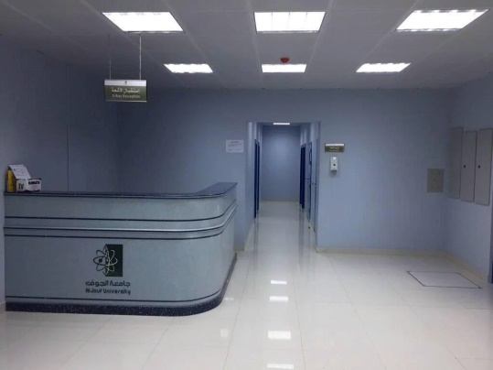
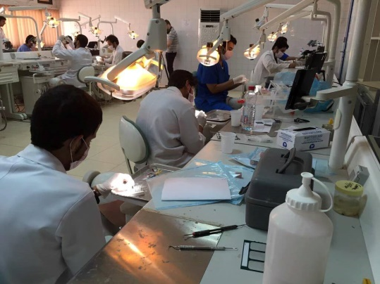
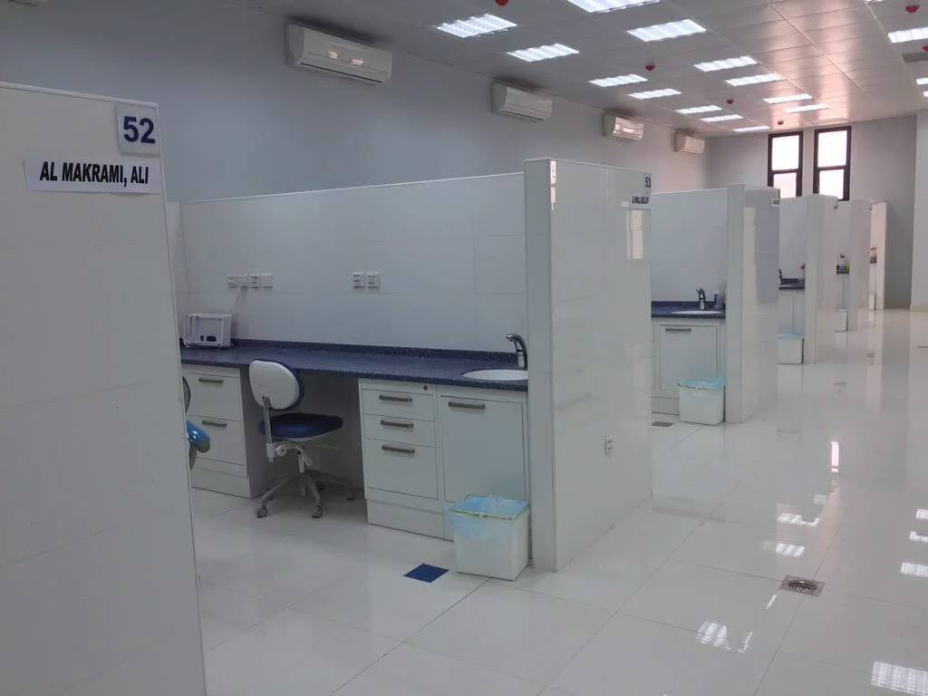
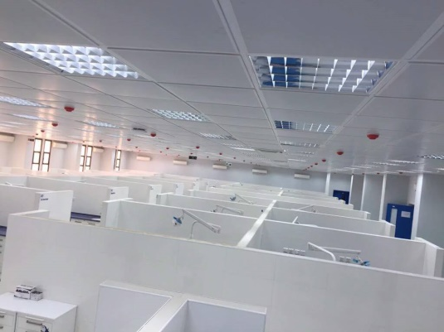
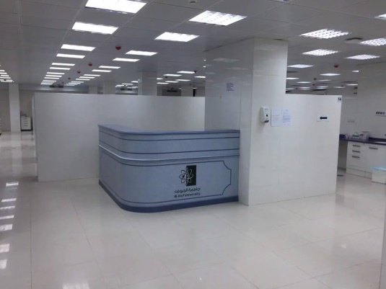
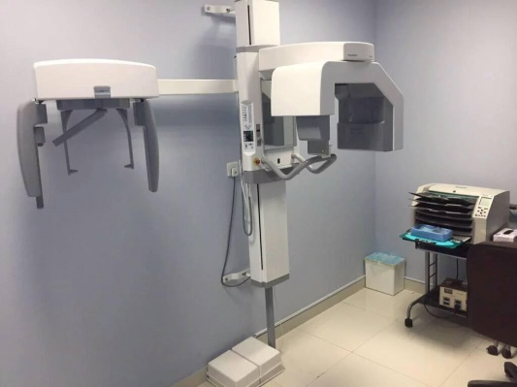
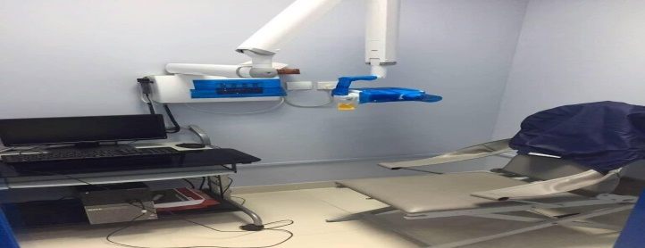
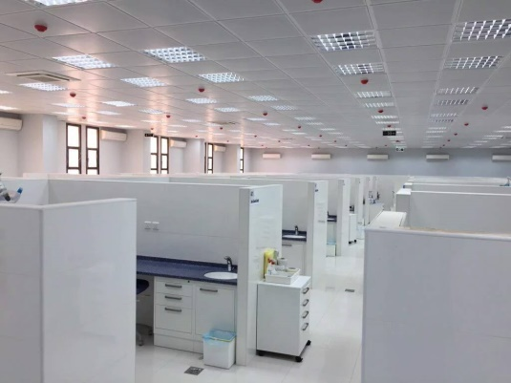

CONTENTS

SUBJECT | PAGE
Abbreviations | 5
Introduction | 6
Principles of infection control | 7
Clinic preparation | 14
Disposal & management of waste materials | 15
Infection control protocol for instruments | 17
Infection control protocol for Radiology and Radiography | 21
Infection control protocol in dental laboratory | 24
Evaluation and grading of infection control procedure in the clinic | 25

ABBREVIATIONS

HGV- Herpes Group of Virus
HSV- Herpes Simplex Virus
EBV-Epstein Bar Virus
CMV-Cytomegalo Virus
HIV-Human Immunodeficiency Virus
PEP- Post exposure prophylaxis
CDCP- Centre for Disease Control & Prevention

INTRODUCTION

I
nfections and other hazards constitute a threat to patients and to those providing dental care. Infection prevention and control is an important part of safe patient care. Concerns about the possible spread of blood-borne diseases, and the impact of emerging, highly contagious respiratory and other illnesses, require practitioners to establish, evaluate, continually update and monitor their infection prevention and control strategies and protocols. The risks must be minimized by adherence to aseptic clinic operations in order to manipulate the presence and potential transmission of infections. Even when healthy, the mouth contains hundreds of potential pathogens. Virtually every class of microorganisms is included among those that can reside in saliva, phlegm, blood, tissue fluid, crevicular fluid, dental plaque, carious lesions as well as in healthy and diseased oral tissues, including the salivary glands. These pathogens include HGV herpes group viruses, (herpes simplex, HSV, Epstein Bars EBV, cytomegalovirus CMV) and HIV. Documented outbreaks of HGV and transmission of HSV in dental clinics indicate the legitimate use of universal precautions for all patients during all dental operations. Universal precautions are intended to prevent parenteral, mucous membrane and non- intact skin exposure to blood and saliva borne pathogens. Other body fluids to which universal precautions apply are not probable to be encountered in the dental practice.

The dental practitioner, dental assistants, dental technicians and students alike have the responsibility of adhering to an infection control protocol that provides for an aseptic clinical environment. This manual addresses the concerns and lists of procedures to be followed when providing services in the clinics. These processes will be continually reviewed and updated in a consecrated endeavor to provide practical guidelines to assure a secure environment for patient handling. All students, supporting staff and faculty members is responsible for carrying our infection control protocols and follow the laid guidelines in this manual. These Guidelines reflect current knowledge of the transmission of infection, and how to prevent and control it.

PRINCIPLES OF INFECTION CONTROL

Infection Control is the responsibility of all of us. The summaries of guidelines are as follows:
- Standard/Universal Precautions are used for ALL patients since it is not possible to tell which patient is infectious. All potentially infectious materials, such as blood or saliva, extracted teeth and tissues are considered infectious for Blood borne Pathogens.
- Exposure Control is to be abided by at all times. This is the practice of preventing any reasonably anticipated eye, skin, mucous membrane, or parenteral contact with blood or other potentially infectious fluids during the execution of one’s responsibilities.
- Immunizations are required for Hepatitis B, Measles, Mumps, Rubella, Diphtheria, Tetanus, Pertussis, and Polio. It is strongly recommended that Dental Health Care Workers also receive yearly tuberculin testing and flu vaccinations. All employees, Students, clinical faculty, dental hygienists, dental assistants, radiology technicians and central sterilization personnel, clinical coordinators and dental laboratory technicians, are at risk of exposure to blood or other potentially infectious material and are required to be vaccinated for hepatitis B or sign a declination.
- Hand Hygiene: Hand Washing is the foremost footfall in the exercise of universal precautions. Rings and watches must be removed before hand washing and glove wearing. Also nails are cut short and no false fingernails. Hand washing is indicated: before treatment and before wearing gloves; between patients; after glove removal; and if you wish to exchange your gloves during the same routines.
- Hand washing technique: Hand washing depends primarily on mechanical effects of rubbing the hands together to produce friction, rinsing with running water and drying. Antimicrobial soaps, which exhibit substantive effect (2-4% Chlorhexidine), can eliminate microorganisms for the continuance of a surgical operation.
HAND WASHING TECHNIQUE

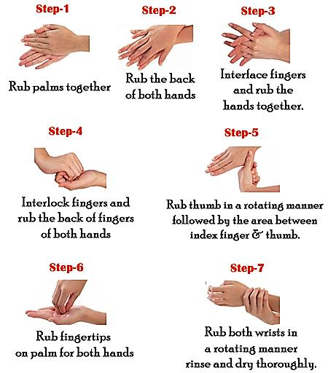

HAND SCRUBBING TECHNIQUE

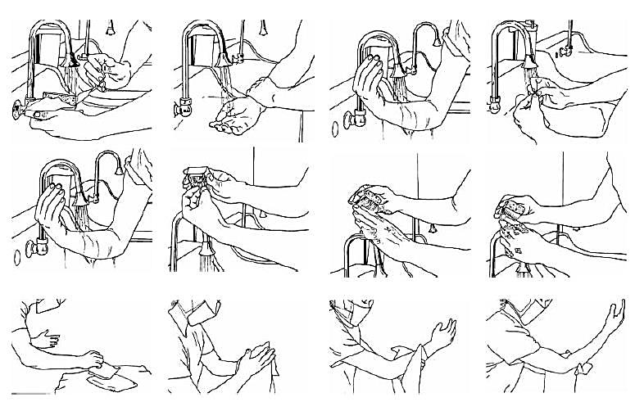

- Personal Protective Equipment is to be worn for ALL patient procedures.
This includes protective eyewear, face shields (mandatory for all routines. Safety glasses for all patients are strongly suggested), clinic gown (with high neck and long arms to prevent skin exposure and to protect street clothes from contamination. One must not wear a clinic gown while traveling outside clinical areas such as the cafeteria, and student lounges. Gowns should be changed at each clinic session, at least daily or when visibly soiled), face mask (masks are mandatory for all dental procedures and must be changed for every patient and when not in use, the mask should be worn on the forehead, around the neck, or hanging from one ear. Always remove gloves before leaving operatory. Use heavy utility gloves for non-treatment purposes such as operatory preparation and clean up. Use vinyl over gloves for quick trips from the operator such as to the amalgamator to prevent pollution). Long and medium length hair must be tied or pinned back.
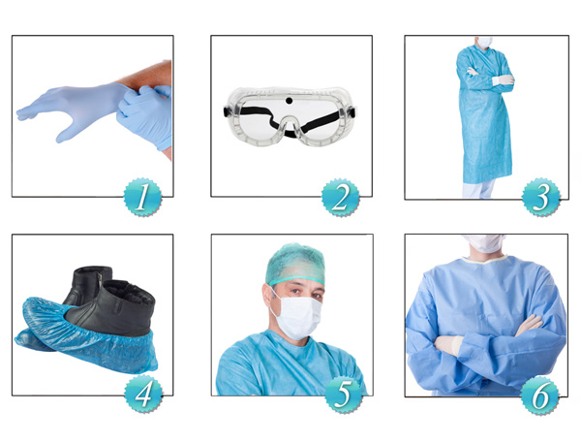

- Sterilization is required for all instruments, burs, and Handpieces by appropriate means (autoclave, dry heat, or ethylene oxide gas sterilization). Items must be dated, kept properly wrapped and sealed until ready to use.
- All instruments and materials classified as sharps should be handled carefully to prevent injury. All sharps must be placed in the puncture resistant sharps container located in each operatory.
  - Handling of sharp edges includes: avoiding injuries and management of needle stick injuries. Percutaneous and permucosal exposure to the bloodline and other body fluids of dental patients poses the single greatest risk of transmission of HIV, Hepatitis B, C and D and other blood borne disease from patient to dental team. Emphasis should be placed on prevention of these incidents by assessing safer devices and work practices. Delay in referral to a qualified medical practitioner in assessing the injury may affect the availability of prophylactic medications that can now be offered to exposed health care workers.
  - Avoiding Injuries: Sharp items such as needles, scalpel blade instruments must be handed with precautions to prevent accidental injuries. Point the sharp end of an instrument away from the hand. Pass syringes with needless pointing away. Avoid handling large numbers of sharp instruments and pick up instruments individually. Dispose of needle and other disposal items immediately after use. Wear heavy utility gloves during cleaning.
- If you sustain a needle-stick injury, take the following actions immediately:
- Wash the wound thoroughly with soap and water.
- Alert your supervisor and initiate the injury reporting system used in your workplace.
- Identify the source patient, who should be tested for HIV, hepatitis B, and hepatitis C infections by seeking consent.
- Report to employee health services, the emergency department, or other designated treatment facility.
- Get tested immediately and confidentially for HIV, hepatitis B, and hepatitis C infections.
- Get post-exposure prophylaxis (PEP) in accordance with CDCP (Centers for Disease Control & Prevention) guidelines when the source patient is unknown or tests positive for:
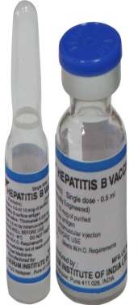
  - HIV: Start prophylaxis within two hours of exposure. HIV PEP should include a four-week regimen of two drugs zidovudine and lamivudine; stavudine ; or didanosine for most exposures and an expanded regimen that includes a third drug for HIV exposures that pose an increased risk for transmission. When the source patient’s virus is known or suspected to be resistant to one or more of the PEP drugs, the selection of drugs to which the source patient’s virus is unlikely to be resistant is recommended.
  - Hepatitis B: If vaccinated no treatment, but if unvaccinated get HBIG and initiate HB vaccine series.
  - Hepatitis C: No treatment is currently recommended. Follow-up:
  - Get confidential follow-up, post-exposure testing at six weeks, three months, and six months, and depending on the risk, at one year.• Receive monitoring and follow-up of PEP.

- Recapping Dental Syringes: Do not remove an uncapped disposable needle from a syringe. Do not recap needles using two hands. Recap the needle using one of the one handed techniques. Do not bend or break needles by hand. Put used needles in a solid sharps container for safety removal of the needle from the body of the syringe. Between multiple injections given with a single needle, place the needle in a clean, safe position where it cannot be contaminated or causes accidental injury or use a safe reheating device.

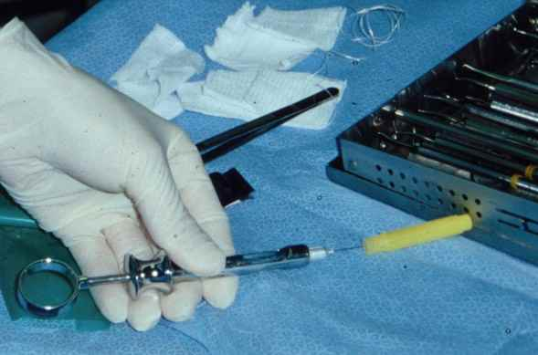

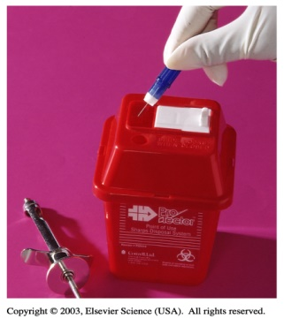

PREPARATION OF CLINIC BEFORE ANY PROCEDURE

- Student infection control procedures posted in each cubicle.
- Flush all water lines for at least 3 minutes.
- Wear personal protective equipment (in order); protective clothing (gown), mask, protective eyewear, wash hands and place gloves.
- Wear heavy-duty gloves to clean and disinfect all working surfaces. Cover (use plastic wrap or tin foil) all touched and disinfected surfaces such as; handles of dental light control switches and bracket tables.
- The student must make every attempt to anticipate all the materials and instruments he will need so that the student does not have to leave his cubicle during an appointment.
- No visits to other students to request or borrow items.
- Minimize touching the mask with gloved hands. Masks become ineffective when it becomes wet. Use fresh mask for every patient. Proper Attire should be with long sleeves and high necks. Change coats daily or whenever required.
- Wear a new pair of gloves for each patient. Do not wash gloves before use or for reuse. Remove gloves that are ruptured or punctured and wash your hands and remove barrier protection (glove-mask-eyewear-gown and wash your hands) before departing work area.
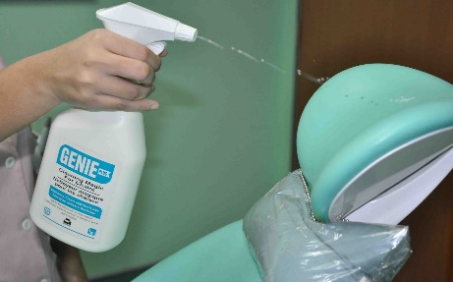
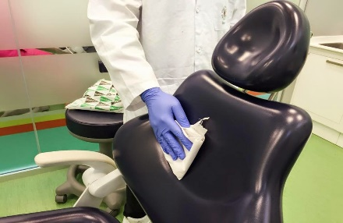
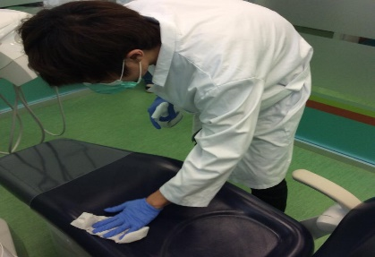
DISPOSAL OF WASTE MATERIALS

- General waste from dental practices is no more infective than residential waste. The majority of soiled items in dental offices is general medical waste and thus can be disposed of with ordinary waste. Examples include used gloves, masks, gowns, lightly soiled gauze or cotton rolls, and environmental barriers (plastic bags) used to cover equipment during treatment.
- Infectious waste that carries a substantial risk of causing infection during handling and disposal is regulated medical waste. Examples of regulated waste found in dental- practice settings are solid waste soaked or sustained by blood or saturated with blood or saliva (gauze saturated with blood and saliva after surgery), extracted teeth, surgically removed hard and soft tissues and contaminated sharp items such as needles, scalpel blades, and wires.

Management of regulated medical waste includes:
- Careful disposal and the use of color-coded or labeled leak-resistant container that prevents leakage (Biohazard bag) to contain non-sharp regulated medical waste.
- Place sharp items (needles, scalpel blades, orthodontic bands, broken metal instruments, and burs) in an appropriate sharps container (puncture resistant, color-coded and leakproof). Close container immediately before removal or replacement to prevent spillage or protrusion of contents during handling, warehousing, transport, or shipping.
- Ensure that dental health care workers who handle and dispose of regulated medical waste are trained in appropriate handling and disposal methods and informed of the possible health and safety hazards.

Management of Biopsy Specimens:
- During shipping, place biopsy specimens in a sturdy, leakproof container labeled within the Biohazard symbol.
- If a biopsy specimen container is visibly contaminated, clean and disinfects the outside of a container or place it in an impervious bag labeled with the Biohazard symbol.

Handling of Extracted Teeth:
- Dispose of extracted teeth as regulated medical waste unless returned to the patient.
- Do not dispose extracted teeth containing amalgam in regulated medical waste intended for incineration.
- Clean and place extracted teeth in a leakproof container, labeled with a Biohazard symbol, and maintain hydration for transport to an educational institution or a dental laboratory.
- Heat-sterilize teeth that do not contain amalgam before they are used for educational purposes.

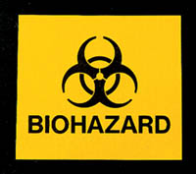
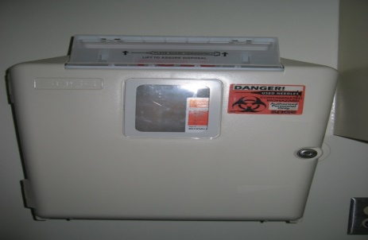
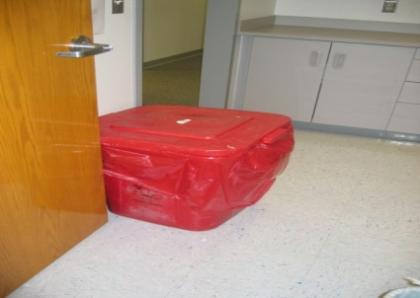
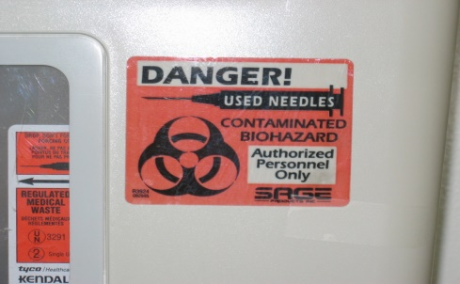

INFECTION CONTROL PROTOCOL FOR INSTRUMENTS

The CDC (1993) classifies instruments and equipment used in the dental practice and the dental laboratory into critical, semi-critical and non-critical instruments.
STATUS | INSTRUMENTS | HOW TO HANDLE
Critical | These are instruments that invade tissues  E.g.:  Scalpels, Scalers, surgical forceps, burs, files. | Sterilization
Semi-critical | These instruments are used intraorally, but do not invade tissue e.g. Amalgam condenser mirror | Sterilization or high level disinfection
Non-critical | Instruments or equipment that does not get inside the mouth, they only contact intact skin e.g.  X-ray cone, parts of face bow | Medium or low level disinfection

The infection control protocols vary from one specialized area to another and they may change from one dental procedure to another. In this section general items of infection control protocols are stated for each dental operatory, e.g. Clinic, lab. Etc. Those protocols should be strictly followed. Any infringement will be considered academic incompetence.

STUDENTS CLINICS:
The cubicles are serially numbered and each student is assigned to a particular cubicle all year long. The cubicle neatness and cleanliness is the student’s responsibility. It is also the student’s responsibility to be sure of the following:
- Remove all used items after each patient treatment. Borrowed items should be returned to the dispensary; used instruments should also be cleaned and prepared for autoclaving.
- Contaminated waste disposal is also the student’s responsibility. Contaminated waste should be placed in assigned plastic bags and sharps are disposed in special puncture-resistant containers.
- At the end of clinical sessions, each student should clean and disinfect his/her cubicle properly (except floor area). Blood spatters should receive high-level disinfection. For example, if the unit sink has spots of visible blood it has to be generously sprayed with full strength cocide wipe, then generously sprayed with cocide again and left to dry (about 10-15 minutes).
- The hand pieces used can be sterilized by autoclaving. Sterilization for the hand pieces is requiring between patients. Steps are as follows:
  - Wipe your hand piece with a clean towel moistened with cocide.
  - Lubricate the hand piece and place it in the autoclave bag.
  - You may give it to CSSD at the close of the day or if you do not need shortly.
  - If you need your hand piece soon, use the fact autoclave in your clinical area. When the hand piece is sterilized, take it out of autoclave bag and operate it for 20 seconds to get rid of lubricants. Then use your lubricant assigned for sterilized handpiece and lubricates it again. Then run it once more for 20-30 seconds.
  - Coverage of frequently used items, e.g. Light handles, chairs, buttons, etc., and proper disposal of covers.
Operatories between patients:
- After patient dismissal, dispose or throw out all materials properly. DO NOT use hands to pick up sharp items. Place all sharps in puncture-resistant container in the hallways.
- Take off gloves used for patient treatment and dispose them.
- To clean the operatory you must still wear a face shield and utility gloves.
- Wipe the hand piece with a disinfectant, then detach from the hose end. Lubricate the hand piece, put into its original autoclave bag, and turn it to central sterilization.
- Remove the used tip from the air water syringe and place it on used instruments tray. Remove use tip from high volume suction end. If disposable, place in the waste container. If non-disposable, place on the used instrument tray.
- Clean and disinfect surfaces that were not covered, suing the spray-wipe-spray technique.
- Take off all coverings and place in the waste container.
- Wipe all used surfaces with cocide and recover them (if another treatment session will start).
- Do not forget to disinfect items such as pens and pencils used during patient handling.
- Be sure to disinfect non-disposable items such as glass slabs, mixing bowls, shade guides, tubes of impression materials etc. before returning them to the dispensary or cart in the clinics.
- Amalgam capsule is disposed in special containers labelled for that purpose in the clinics.
End of day procedures:
- All operatories must be cleaned as between patients and items covered should be disinfected.
- Flush all dental unit and scaler for 3 minutes.
- The dental assistant should thoroughly clean suction lines of each unit by:
- Orotol: follow directions on the container.
- Household bleach or A cup bleach - 1 gallon water.

INFECTION CONTROL PROTOCOL FOR RADIOLOGY
Each x-ray room is equipped with a dental chair and x-ray machine. The control buttons are located outside the room.
The following steps should be strictly followed for x-ray taking:
- Before seating the patient:
- Use surface disinfectant to spray:
- Hand-control exposure buttons.
- Chair, head rest.
- Chair switches.
- Tube head.
- Lead apron, collar.
- Prepare the following:
- Film(s) in disposable cup.
- Cotton rolls.
- Styrofoam bite blocks/bite wing tabs.
- Seat Patients
- Place covers: lead apron, collar.
- Bib napkin.
- During the Procedure:
- Always use barrier techniques
- Gloves.
- Masks.
- Eye ware or face shields.
- Use films in envelopes.
- Place exposed (contaminated) films in plastic cups.
- After the Procedure:
- Hang up lead apron and collar.
- Set aside plastic cup with exposed film(s).
- Dispose of all disposables, e.g. Styrofoam bite blocks, cotton rolls, bite wing tabs etc.
- Film Processing:
- Wear protective gloves.
- Set 2 clean cups.
- Remove plastic film shields without touching films and drop film into one of the clean cups.
- Repeat if you have more than one film.
- Dispose cup of films and also of gloves.
- Wash hands thoroughly..
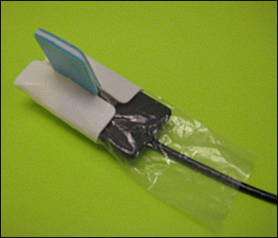
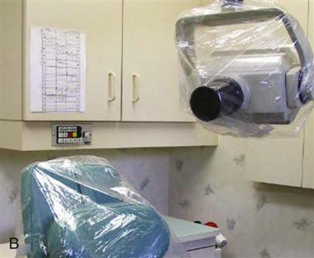
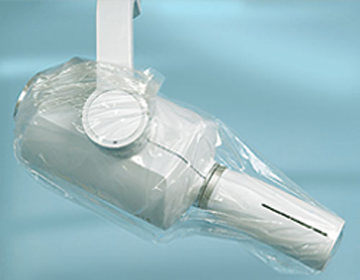
- Process films.

Panoramic and lateral cephalometric infection control guidelines
- Use bite block baggie. Patient can remove the baggie when the x-raying is completed.
- Before and after exposure wipe down the patient positioning area and handles of the panoramic unit and head- and ear- positioning devices on the lateral ceph unit.
Precautions to minimize contamination of digital sensors:
- Apply a surface barrier to reduce cross contamination during use.
- Ensure that the barrier extends onto any section of the cord that may contact mucous membranes.
- Clean and disinfect with intermediate level disinfectant after each patient to minimize the potential for the device associated infections.
Precautions to minimize contamination of information processing system equipment:
- Use disinfectant wipes.
- Use liquid proof mice and keyboards, which will permit the usage of liquid disinfectants; Or: Reusable form fitted barriers that can be cleaned and disinfected be changed between patients.

INFECTION CONTROL PROTOCOL IN DENTAL LABORATORY

- Use PPE when handling items received in the laboratory until they have been decontaminated.
- Before they are handled in the laboratory, clean, disinfect, and rinse all dental prosthesis and Prosthodontic materials (impressions, bite registrations, occlusal rims, and extracted teeth) by using intermediate-level disinfectants.
- Look up with manufacturers regarding the stability of specific materials (printing materials) relative to disinfection procedures.
- Clean and heat sterilize heat-tolerant items used in the mouth (metal impression trays).
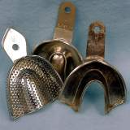
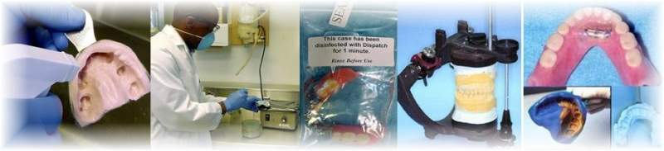
- Clean and heat sterilizes heat tolerant or disinfects items that becomcontaminated, butut do not normally contact the patients (burs, polishing points, rag wheels, and articulators).
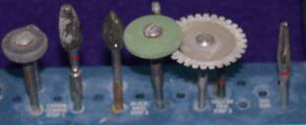
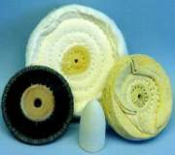
INFECTION CONTROL PROCEDURES IN THE CLINIC

Evaluation and grading of infection control procedures in the clinic:
What should faculty member check for?
    - Students forget to wear the gloves and mask.
    - Neglect washing hands before and after using the gloves.
    - Wrong way in discharging the sharp instruments.
    - Neglect discarding gloves and masks when leaving the dental unit.
    - Leave the operating area not clean after dismissing the patient.
    - Contact non-operating surfaces with gloved hand.
    - Pick/reuse of falling down instruments.
    - Shake hands his colleagues or patient while wearing the gloves.
    - Long nails/hair.
    - Messy patient during the procedure.
    - Students are holding out the proper attire and protective barriers.
    - No gloves outside the cubicles except with over-gloves.
    - No disposal of gowns outside the clinical areas.

BIBLIOGRAPHY

1. Infection control in the Dental environment. Martin Dunitz, University Press, Cambridge 2nd Ed. 1993.
2. American Dental Association council on dental Therapeutics and Council on Prosthetic Services and Dental Laboratory Relations. Guidelines for Infection control in the Dental office and Commercial Dental Laboratory. JAM Dent. Assoc. (1985) 110: 969-72.
3. Centers for Disease Control, Recommended infection control practices for dentistry. MMWR (1986) 35:237-42.
4. Mitchell R. Russel J. The elimination of cross infection in dental practice a fine year follow-up. Br Dent J (1989) 166: 209-11.

