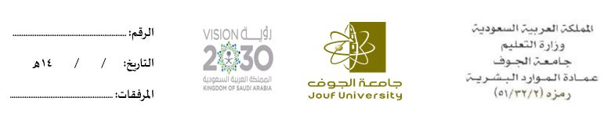
نموذج طلب بدل ......................................................

الاسم |  | المسمى الوظيفي
المرتبة |  | الرقم الوظيفي

- المهام المكلف بها الموظف:
- ......................................................................................................... .
- ......................................................................................................... .
- ......................................................................................................... .
- ......................................................................................................... .

رأي المدير المباشر:

يمارس لا يمارس

الاسم: ............................................................................ التوقيع: ............................................................................

