Title
A THESIS
Submitted to Department Name of the College of Science
Jouf University

By
Student Name

Supervisory Committee
DR. Name
DR. Name

In Partial Fulfillment of the Requirements
for the Degree of
MASTER OF SCIENCE
Major Program:
Program Name
Department Name

Month Year
Sakaka, Al Jouf

Jouf University
College of Science
Department Name
Title
 | -------------------------
 | By
 | ------------
 | The Supervisory Committee certifies that this disquisition complies with Jouf University’s regulations and meets the accepted standards for the degree of
 | MASTER of SCIENCE
 | SUPERVISORY COMMITTEE:
 | Chair
 | Approved:
 |  |  | Name of Dept. Chair
 | Date |  | Department Chair

ABSTRACT
Abstracts for doctoral dissertations must use 350 words or less. Abstracts for master’s papers or master’s theses must use 150 words or less.

ACKNOWLEDGMENTS
Acknowledgments text should be placed here.

DEDICATION
This section dedicates the disquisition to a few significant people. The text must be double spaced and aligned center to the page.

TABLE OF CONTENTS

ABSTRACT iii
ACKNOWLEDGMENTS iv
DEDICATION v
LIST OF TABLES vii
LIST OF FIGURES viii
LIST OF ABBREVIATIONS ix
LIST OF SYMBOLS x
LIST OF APPENDIX TABLES xi
LIST OF APPENDIX FIGURES xii
1. Chapter 1
1.1. First Level Subheading 1
1.1.1. Second Level Subheading 1
2. Subchapter 3
3. Subchapter-2 3
REFERENCES 3
APPENDIX A. APPENDIX MATERIAL 4
APPENDIX B. ADDITIONAL INFORMATION 5

LIST OF TABLES
Table Page
1. Title of Table. 1

LIST OF FIGURES
Figure Page
1. Title of Figure. (If you use a table, figure, or non-text item that is not your original design, you must cite the original source of the item. You may use an in-text citation in the text of the title or caption of the item, or you may include the citation as a footnote. Refer to the style manual of your discipline for more information about citations of non-text items.) 2

LIST OF ABBREVIATIONS
Abbreviation Explanation of the Abbreviation.
TM…………………………………………………… .. Transition metal
MRAM………………………………………………… . Magnetic Random Access Memories
FeRAM ……………………………………………...…..Ferroelectric Random Access memories
FIM ………………………………………………..…….Ferrimagnetic
ME………………………………..……………………... Magnetoelectric
BTO……………………………………………………... BaTiOs

LIST OF SYMBOLS
Symbol Explanation of Symbol. If the symbol text runs longer than one line, the subsequent lines are aligned with the first word in the entry.
ɛ_{o} …………………………………………………………………….Permittivity o f free space
ɛ' ……………………………………………………………………..Dielectric constant
P_{s} …………………………………………………………………….Spontaneous Polarization
T_{c} …………………………………………………………………….Curie temperature

LIST OF APPENDIX TABLES
Table Page
A1. Title of Appendix Table. 4

LIST OF APPENDIX FIGURES
Figure Page
A1. Title of Figure. 4

- Chapter
Paragraph text paragraph text paragraph text paragraph text paragraph text paragraph text paragraph text paragraph text paragraph text paragraph text paragraph text paragraph text paragraph text paragraph text paragraph text paragraph text paragraph text paragraph text paragraph text paragraph text paragraph text paragraph text paragraph text paragraph text paragraph text paragraph text paragraph text paragraph text paragraph text paragraph text paragraph text paragraph text
- Bulleted list items use the “Bullets” style from the styles pane.
  - First Level Subheading
Paragraph text paragraph text paragraph text paragraph text paragraph text paragraph text paragraph text paragraph text paragraph text paragraph text paragraph text paragraph text
Table 1. Title of Table.
Column 1 | Column 2 | Column 3 | Column 4
Row 1
Row 2
Table note.
    - Second Level Subheading
Paragraph text paragraph text paragraph text paragraph text paragraph text paragraph text paragraph text paragraph text paragraph text paragraph text paragraph text paragraph text paragraph text paragraph text paragraph text paragraph text paragraph text paragraph text
      - Third level subheading

Paragraph text paragraph text paragraph text paragraph text paragraph text paragraph text paragraph text paragraph text paragraph text paragraph text paragraph text paragraph text paragraph text

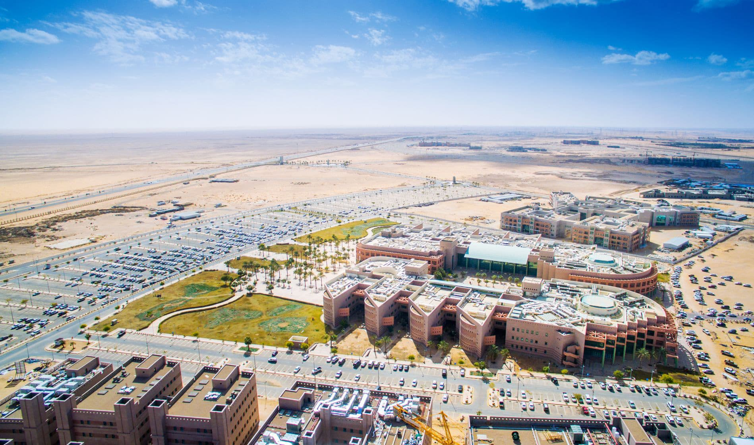
Figure 1. Title of Figure. (If you use a table, figure, or non-text item that is not your original design, you must cite the original source of the item. You may use an in-text citation in the text of the title or caption of the item, or you may include the citation as a footnote. Refer to the style manual of your discipline for more information about citations of non-text items.)
Figure Note: This style is used for any notes related to a figure.

- Subchapter
- Subchapter-2

REFERENCES
Citation citation citation citation citation citation citation citation citation citation citation citation citation citation citation citation citation citation citation citation citation citation citation
Citation citation citation citation citation citation citation citation citation citation citation citation citation citation
Last Name, First Initial.; Last Name, First Initial. "Title". Journal, Year, Volume (issue), Pages

APPENDIX A. APPENDIX MATERIAL
Please read our appendix format guidelines thoroughly, as they contain specific instructions pertaining to how your appendix material should be presented.
Table A1. Title of Appendix Table.
Column 1 | Column 2 | Column 3 | Column 4
Row 1
Row 2
Table note.
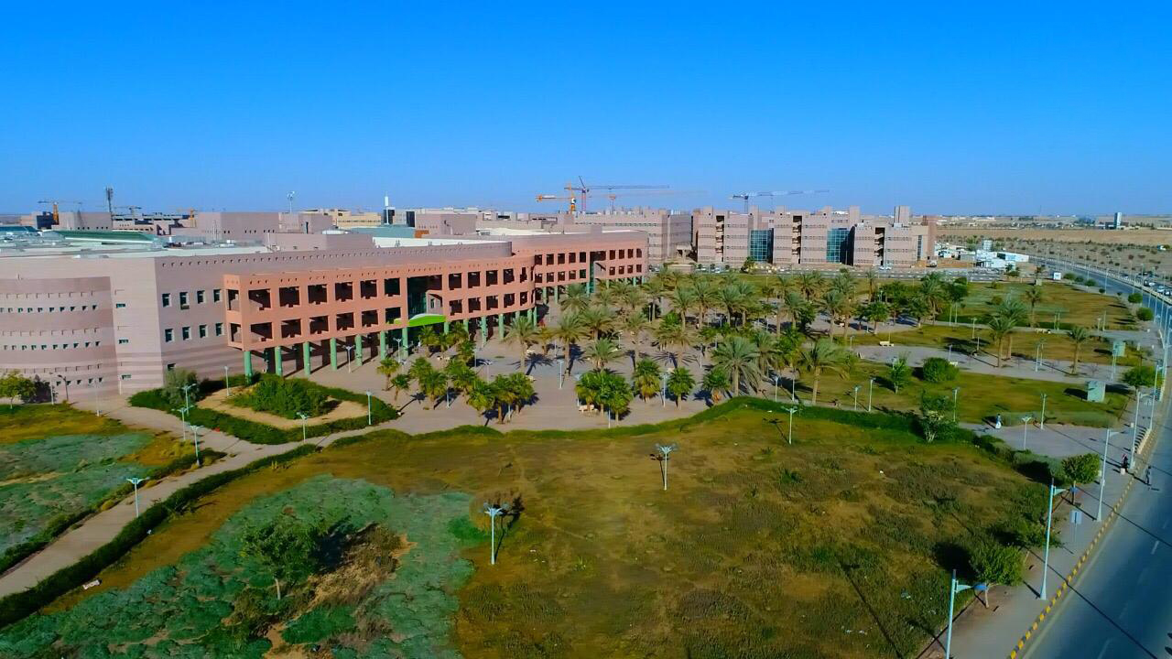
Figure A1. Title of Figure.
Figure Note: used for any figure notes.

APPENDIX B. ADDITIONAL INFORMATION
For more information about disquisitions, timelines, deadlines, graduation requirements, and other resources, see the Graduate School and College of Science websites.
For more information about the guidelines for electronic submission of disquisitions, and for downloadable templates of disquisition sections, see the online Format Guidelines at Graduate School and College of Science websites.
For more information about citations, academic honesty, and how to use style manuals, contact the Graduate Center for Writers to make an appointment for a writing consultation. Additional resources are also available on the Graduate School and College of Science website.
For more information about using Microsoft Word and other software applications, contact the Graduate School and College of Science website.

